Name: B.Vinayani
Registration Number: 192472179

EXPERIMENT 2
Zero-shot, One-shot and Few-shot Prompts - 200-word Blog on "Applications of Artificial Intelligence in Healthcare"

AIM
To design zero-shot, one-shot and few-shot prompts for generating a 200-word blog on "Applications of Artificial Intelligence in Healthcare" and to compare the outputs.

PROCEDURE
1. Open an LLM chat interface (such as ChatGPT, Gemini or Claude) in a new chat.
2. Zero-shot: enter an instruction that describes only the task (write a 200-word blog on the given topic) without any example, and note the response.
3. One-shot: start a new chat and enter the same instruction together with ONE worked example, followed by the actual task. Note the response.
4. Few-shot: start a new chat and enter the same instruction together with TWO worked examples, followed by the actual task. Note the response.
5. Capture a screenshot of each prompt with its generated output.
6. Compare the three outputs and record the observations.

PROMPTS (CODE)
Zero-shot prompt:
Write a 200-word blog on "Applications of Artificial Intelligence in Healthcare."

One-shot prompt:
Write a 200-word blog in the same structure as the example (title, intro, three numbered applications, conclusion).

Example:
Title: AI in Education - Learning That Adapts
Intro: Artificial Intelligence is changing how students learn and teachers teach.
1. Personalised learning: Adaptive platforms adjust lessons to each student's pace.
2. Smart assessment: Automated grading gives instant feedback and saves teachers time.
3. Virtual tutors: Chatbots answer doubts at any hour.
Conclusion: Used wisely, AI supports teachers and helps every learner succeed.

Now write a 200-word blog on: "Applications of Artificial Intelligence in Healthcare."

Few-shot prompt:
Write a 200-word blog following the structure of the examples (title, intro, three numbered applications, conclusion).

Example 1:
Title: AI in Education - Learning That Adapts
Intro: Artificial Intelligence is changing how students learn and teachers teach.
1. Personalised learning: Adaptive platforms adjust lessons to each student's pace.
2. Smart assessment: Automated grading gives instant feedback and saves teachers time.
3. Virtual tutors: Chatbots answer doubts at any hour.
Conclusion: Used wisely, AI supports teachers and helps every learner succeed.

Example 2:
Title: AI in Agriculture - Smarter Farming
Intro: Farmers are turning to Artificial Intelligence to grow more with less.
1. Crop monitoring: Drones and image analysis spot disease early.
2. Yield prediction: Models forecast harvests from weather and soil data.
3. Precision irrigation: Sensors water crops only when needed.
Conclusion: AI helps farmers save resources and secure food for the future.

Now write a 200-word blog on: "Applications of Artificial Intelligence in Healthcare."

OUTPUT
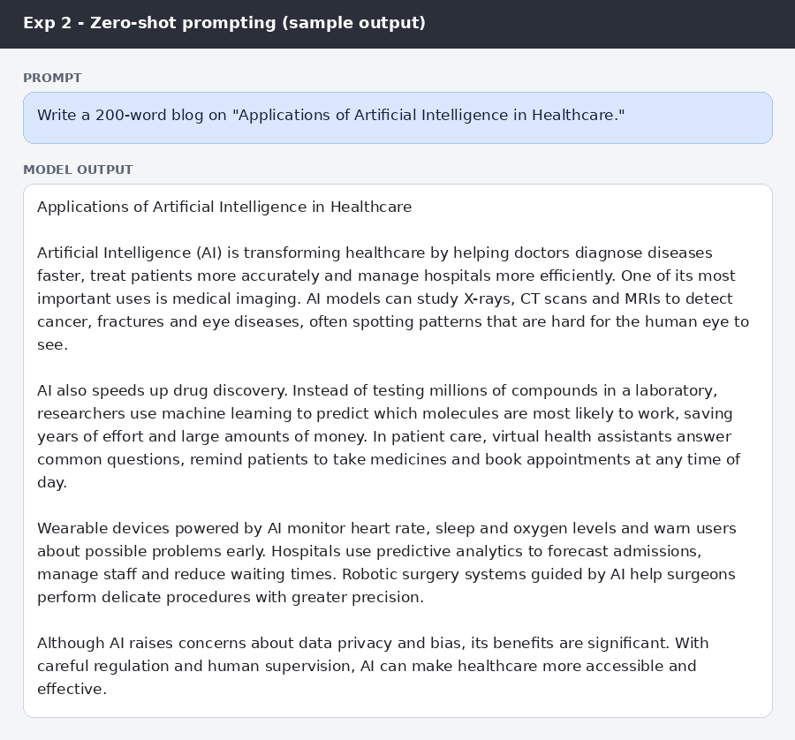
Figure: Zero-shot prompt and sample blog
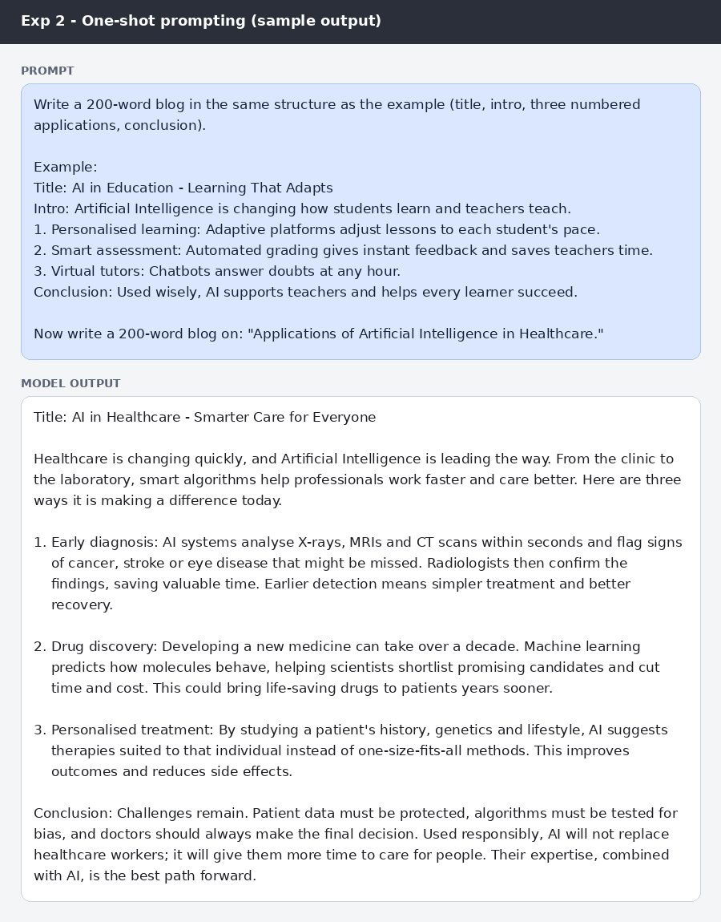
Figure: One-shot prompt and sample blog
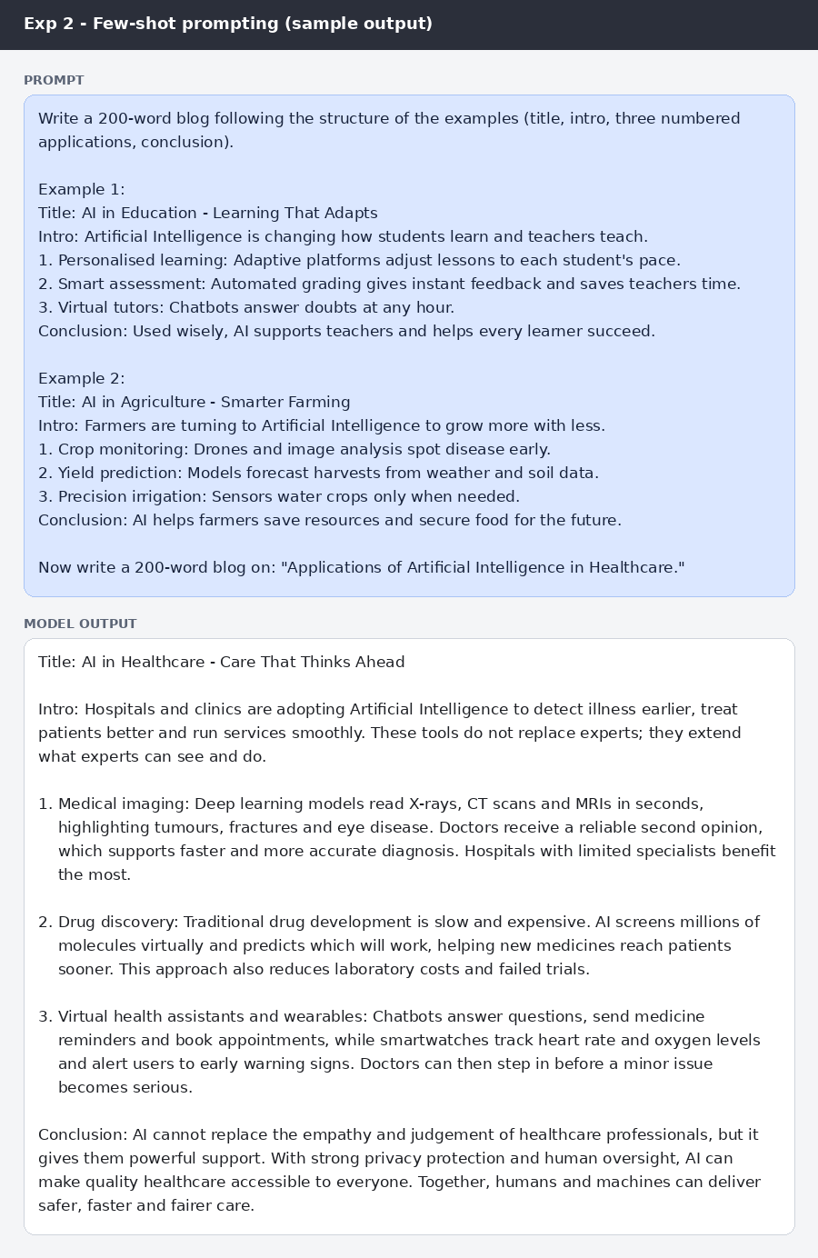
Figure: Few-shot prompt and sample blog

RESULT
The three outputs contained 196, 203 and 202 words respectively, all close to the 200-word target. The zero-shot blog was written as flowing paragraphs, whereas the one-shot and few-shot blogs followed the title, introduction, three numbered applications and conclusion structure given in the examples, which made them easier to scan.

CONCLUSION
All three prompting styles produced relevant blogs of about 200 words, but examples control the structure. One-shot and few-shot prompts gave a predictable layout, so they are preferred when a fixed blog format is required.

